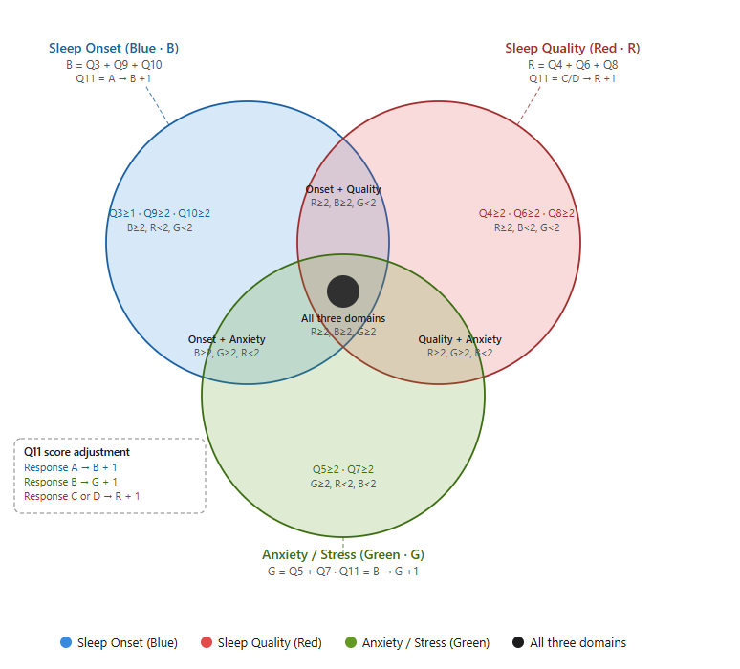

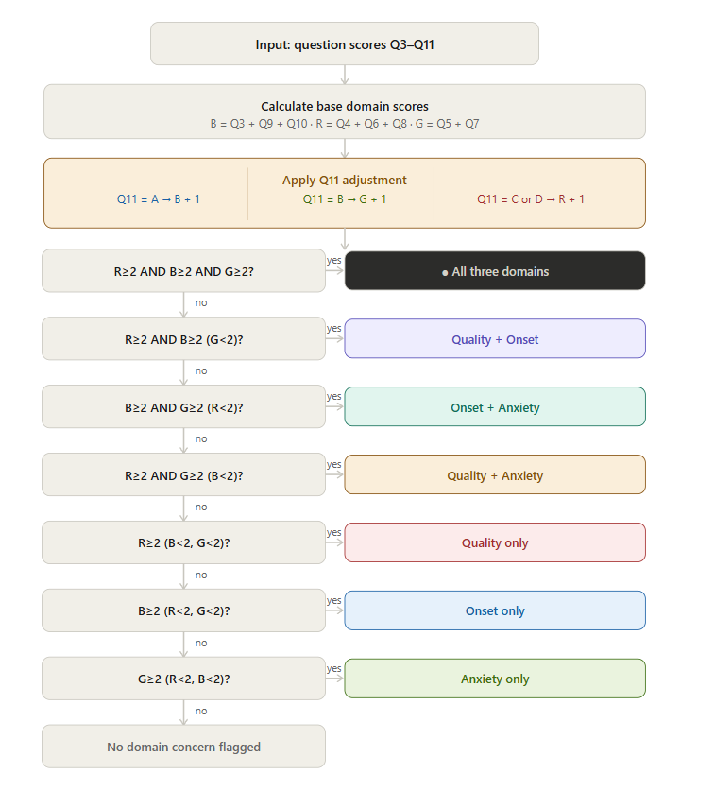

Edge cases below:

- When R + B + G =1;
If R=1 or G = 1 or B =1 ;
Status: “No major sleep issues detected”
Text section mapped with “ NO DOMAIN / HEALTHY (EDGE CASE)”
- When R + B + G = 2 where each of R,G,B is not 2
Status: “No major sleep issues detected”
Text section mapped with “ NO DOMAIN / HEALTHY (EDGE CASE)”
- When R=1& B=1& G =1
Status: “No major sleep issues detected”
Text section mapped with “ NO DOMAIN / HEALTHY (EDGE CASE)

PRODUCT SUGGESTION
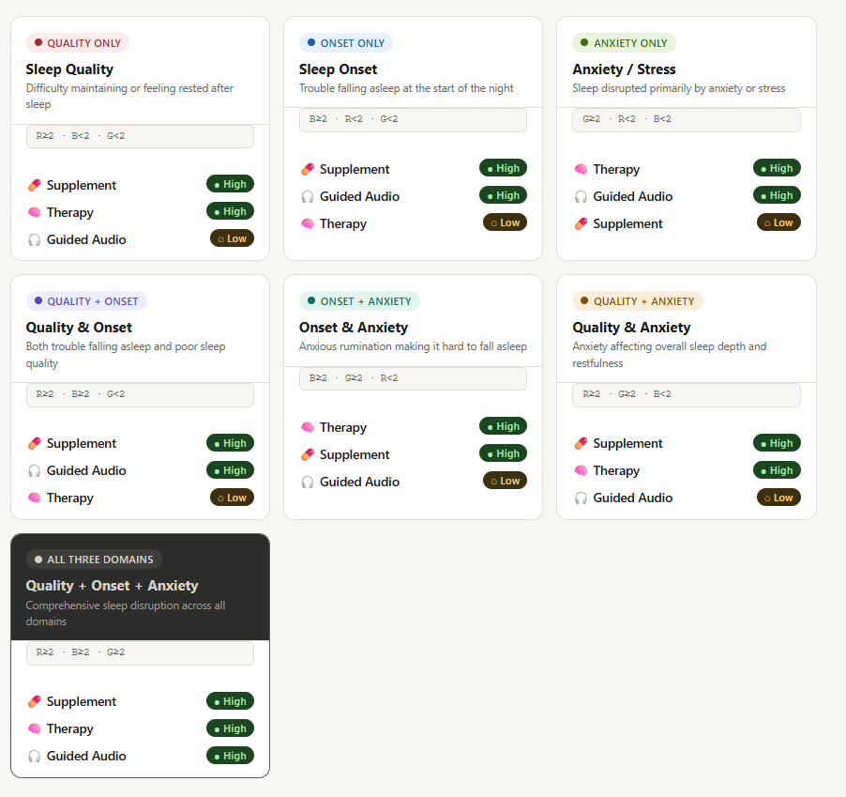

Dynamic Text Section

🔵 ONSET ONLY
Headline: Falling asleep might be taking longer than it should
Insight: You are probably able to sleep through the night, but getting there might take some time
Reassurance: This is quite common and usually responds well to small changes
Action framing: We’ll help you ease into sleep more naturally

🔴 QUALITY ONLY
Headline: Your sleep may not feel as restorative as it could be
Insight: You are maybe falling asleep without much trouble, but the depth or continuity of sleep might be lacking
Reassurance: Improving sleep quality often doesn’t require more time in bed, just better cycles
Action framing: We’ll help you wake up feeling more refreshed and recovered

🟢 ANXIETY ONLY
Headline: Your mind might be staying a little active at night
Insight: There could be some level of stress or overthinking that shows up around bedtime
Reassurance: This doesn’t mean something is wrong, it just means your system hasn’t fully unwound yet
Action framing: We’ll help you settle your mind and ease into rest

🟣 QUALITY + ONSET
Headline: Both falling asleep and staying in deep sleep might need support
Insight: It seems like it takes time to fall asleep, and the sleep itself may not feel fully restorative
Reassurance: When both are addressed together, improvements tend to compound quickly
Action framing: We’ll help you transition into sleep smoothly and improve its depth

🟢🔵 ONSET + ANXIETY
Headline: A busy mind might be delaying your sleep
Insight: You may notice thoughts or restlessness that makes it harder to drift off
Reassurance: This pattern is quite responsive to calming and grounding routines
Action framing: We’ll help you slow things down and fall asleep with less effort

🔴🟢 QUALITY + ANXIETY
Headline: Stress might be affecting how deeply you sleep
Insight: Even if you fall asleep, your system may not fully switch into deeper, restorative states
Reassurance: As your mind relaxes, sleep quality often improves alongside it
Action framing: We’ll help you unwind more deeply and improve recovery during sleep

⚫ ALL THREE DOMAINS
Headline: Your sleep might feel a bit off across multiple areas
Insight: Falling asleep, staying asleep, and mental calmness may all be interacting here
Reassurance: This can feel layered, but it also means there’s room for meaningful improvement
Action framing: We’ll guide you through a more complete reset of your sleep patterns

⚪ NO DOMAIN / HEALTHY (EDGE CASE)
Headline: Your sleep seems to be in a fairly good place
Insight: There are no strong signs of disruption based on your responses
Reassurance: Maintaining this is just as important as fixing issues
Action framing: We’ll help you protect and further optimize your sleep

Questions:

What is your Age Bracket?
  - <18
  - 18–25
  - 26–35
  - 36–45
  - 46+

What is your gender? (Sleep patterns and challenges can vary across genders)
  - Female
  - Male
  - Non-binary
  - Prefer not to say

How often do you struggle to fall asleep, even when you feel tired?
  - Rarely (0–1 nights a week)
  - Sometimes (2–3 nights a week)
  - Often (4–6 nights a week)
  - Almost always (every night)

How often do you wake up during the night or earlier than you intended?
  - Never
  - Occasionally
  - Frequently
  - Most Nights

How often do you experience overthinking, anxiety, or restlessness before going to bed?
  - Never
  - Occasionally
  - Frequently
  - Most Nights

How refreshed do you feel in the morning after sleep?
  - Fully refreshed
  - Somewhat refreshed
  - Usually tired or groggy

How long have you been experiencing sleep difficulties?
  - Less than 2 weeks
  - 2–4 weeks
  - 1–3 months
  - 3–6 months
  - More than 6 months

On average, how many hours of restful sleep do you get each night?
  - 7–8 hours
  - 5–6 hours
  - Less than 5 hours

How regular is your sleep schedule (bedtime and sleep time)?
  - Very regular, I sleep and wake at nearly the same time daily
  - Somewhat regular, small variations depending on the day
  - Irregular, my sleep timing changes often
  - Very irregular, no fixed pattern
- When do you typically put your electronic devices away for the night? (SH >=2)
  - More than 60 minutes before bed
  - 30–60 minutes before bed
  - 15–30 minutes before bed
  - Less than 15 minutes before bed
  - Right before bed

What would you most like to improve about your sleep? (Select all that apply)
  - Falling asleep faster
  - Reducing anxiety before bed
  - Staying asleep through the night
  - Waking up more refreshed

What benefits are you most excited to experience with better sleep? (Select all that apply)
  - I would feel more energetic and less tired during the day
  - My mind would feel calmer and less overactive
  - I would stop worrying about sleep and fall asleep more easily
  - I would stay asleep through the night without waking up
  - I would wake up feeling refreshed and well-rested
  - I would be able to focus and function better in my daily life

Prompt for the Developers:

1. Overview
After a user completes the Sleep Assessment (11 questions), compute their sleep domain scores and render a personalised results page. The page sits within the existing Nervaya site — white background, purple (#7C3AED) primary accent, dark navy (#0D0D1A) text, Inter/sans-serif typography consistent with the existing UI. The page has three stacked sections: Status Banner → Dynamic Insight → Service Recommendations.

2. Input Data
Questions Q3–Q10 use 0-indexed ascending values (first option = 0, last option = optionCount - 1). Q1 and Q2 are not used in scoring. Q11 is a special single-select question with options A/B/C/D and does not follow this pattern.
The number of options per question is defined in a central configuration object that must be the single source of truth across both the scoring logic and the question rendering. Any future change to the number of options for a question must only require updating this config — no changes elsewhere.
js
// QUESTION CONFIG — update here only when changing number of options
const QUESTION_CONFIG = {
Q3: { options: 4 }, // max value = 3
Q4: { options: 4 }, // max value = 3
Q5: { options: 4 }, // max value = 3
Q6: { options: 3 }, // max value = 2
Q7: { options: 5 }, // max value = 4
Q8: { options: 3 }, // max value = 2
Q9: { options: 4 }, // max value = 3
Q10: { options: 5 }, // max value = 4
};

// Scoring uses the raw 0-indexed response value directly.
// Max value for any question = QUESTION_CONFIG[Qn].options - 1
Important: The ≥2 classification threshold for B, R, and G is a fixed design threshold and is intentionally independent of the number of options per question. It does not auto-scale when options change. If you significantly reduce the number of options on a scoring question (e.g. from 5 to 2), review whether the ≥2 threshold still makes clinical sense for that domain and adjust it manually in the classification logic

3. Score Calculation

Step 1 — Base domain scores
B (Sleep Onset) = Q3 + Q9 + Q10
R (Sleep Quality) = Q4 + Q6 + Q8
G (Anxiety/Stress)= Q5 + Q7

Step 2 — Q11 adjustment (apply after base scores)
Q11 = A → B = B + 1
Q11 = B → G = G + 1
Q11 = C → R = R + 1
Q11 = D → R = R + 1

4. Segment Classification (Sequential If-Else)
Evaluate conditions in this exact order, assign the first match:
1. if R≥2 AND B≥2 AND G≥2 → Segment: ALL_THREE
2. else if R≥2 AND B≥2 → Segment: QUALITY_ONSET
3. else if B≥2 AND G≥2 → Segment: ONSET_ANXIETY
4. else if R≥2 AND G≥2 → Segment: QUALITY_ANXIETY
5. else if R≥2 → Segment: QUALITY_ONLY
6. else if B≥2 → Segment: ONSET_ONLY
7. else if G≥2 → Segment: ANXIETY_ONLY
8. else (max(R,B,G) < 2) → Segment: NO_DOMAIN
Note on edge cases for NO_DOMAIN: Any combination where no single score reaches 2 — including all zeros, any one score = 1, two scores = 1, or R=B=G=1 — all resolve to NO_DOMAIN via the single rule max(R,B,G) < 2. No need to check these sub-cases individually.

5. Status Label per Segment
Segment | Status Label
ONSET_ONLY / QUALITY_ONLY / ANXIETY_ONLY | Mild Sleep Issues Detected
QUALITY_ONSET / ONSET_ANXIETY / QUALITY_ANXIETY | Moderate Sleep Issues Detected
ALL_THREE | Severe Sleep Issues Detected
NO_DOMAIN | No Major Sleep Issues Detected

6. Dynamic Text per Segment
Each segment maps to four text fields: Headline, Insight, Reassurance, Action Framing. These replace any static card subtitles.
ONSET_ONLY
- Headline: Falling asleep might be taking longer than it should
- Insight: You are probably able to sleep through the night, but getting there might take some time
- Reassurance: This is quite common and usually responds well to small changes
- Action Framing: We'll help you ease into sleep more naturally
QUALITY_ONLY
- Headline: Your sleep may not feel as restorative as it could be
- Insight: You are maybe falling asleep without much trouble, but the depth or continuity of sleep might be lacking
- Reassurance: Improving sleep quality often doesn't require more time in bed, just better cycles
- Action Framing: We'll help you wake up feeling more refreshed and recovered
ANXIETY_ONLY
- Headline: Your mind might be staying a little active at night
- Insight: There could be some level of stress or overthinking that shows up around bedtime
- Reassurance: This doesn't mean something is wrong, it just means your system hasn't fully unwound yet
- Action Framing: We'll help you settle your mind and ease into rest
QUALITY_ONSET
- Headline: Both falling asleep and staying in deep sleep might need support
- Insight: It seems like it takes time to fall asleep, and the sleep itself may not feel fully restorative
- Reassurance: When both are addressed together, improvements tend to compound quickly
- Action Framing: We'll help you transition into sleep smoothly and improve its depth
ONSET_ANXIETY
- Headline: A busy mind might be delaying your sleep
- Insight: You may notice thoughts or restlessness that makes it harder to drift off
- Reassurance: This pattern is quite responsive to calming and grounding routines
- Action Framing: We'll help you slow things down and fall asleep with less effort
QUALITY_ANXIETY
- Headline: Stress might be affecting how deeply you sleep
- Insight: Even if you fall asleep, your system may not fully switch into deeper, restorative states
- Reassurance: As your mind relaxes, sleep quality often improves alongside it
- Action Framing: We'll help you unwind more deeply and improve recovery during sleep
ALL_THREE
- Headline: Your sleep might feel a bit off across multiple areas
- Insight: Falling asleep, staying asleep, and mental calmness may all be interacting here
- Reassurance: This can feel layered, but it also means there's room for meaningful improvement
- Action Framing: We'll guide you through a more complete reset of your sleep patterns
NO_DOMAIN
- Headline: Your sleep seems to be in a fairly good place
- Insight: There are no strong signs of disruption based on your responses
- Reassurance: Maintaining this is just as important as fixing issues
- Action Framing: We'll help you protect and further optimize your sleep

7. Service Recommendation Logic
The three services map to existing site sections:
- Supplement → Sleep Elixir product page
- Therapy → Therapy Corner
- Guided Audio → Deep Rest

Priority table per segment
Cards are rendered left to right / top to bottom in priority order. High = show "Highly Recommended" badge. Low = show card without badge. None = show card with no priority tag.
Segment | Service Order & Priority
QUALITY_ONLY | Supplement (High), Therapy (High), Guided Audio (Low)
ONSET_ONLY | Supplement (High), Guided Audio (High), Therapy (Low)
ANXIETY_ONLY | Therapy (High), Guided Audio (High), Supplement (Low)
QUALITY_ONSET | Supplement (High), Guided Audio (High), Therapy (Low)
ONSET_ANXIETY | Therapy (High), Supplement (High), Guided Audio (Low)
QUALITY_ANXIETY | Supplement (High), Therapy (High), Guided Audio (Low)
ALL_THREE | Supplement (High), Therapy (High), Guided Audio (High)
NO_DOMAIN | Supplement (None), Therapy (None), Guided Audio (None)

8. UI Specification

General
- Background: White (#FFFFFF) for this page
- Brand accent: Purple #7C3AED
- Text primary: Dark navy #0D0D1A
- Text secondary: #6B7280
- Border radius: 16px on cards
- Font: Match existing site (Inter or equivalent sans-serif)
- Page max-width: 1200px, centred

Section 1 — Status Banner
A full-width pill or banner card near the top of the page. Contains:
- Small all-caps label: SLEEP ASSESSMENT
- Large bold status text: e.g. Moderate Sleep Issues Detected
- Subtext: Based on your responses, here is what we found.
- A subtle left-border or background tint colour-coded by severity:
  - Mild → soft blue tint
  - Moderate → soft amber tint
  - Severe → soft red tint
  - No Domain → soft green tint

Section 2 — Dynamic Insight Block
A clean contained card or section below the banner. Contains:
- Headline — large (~24px), bold, dark navy
- Insight — body text (~16px), secondary colour
- Reassurance — body text, slightly muted, optionally in italics
- Action Framing — body text, purple accent colour, acts as a transition line into the service section
Optional: A thin horizontal divider or subtle icon (moon/star consistent with Nervaya branding) above the headline.

Section 3 — Service Recommendation Cards
Three cards in a responsive 3-column grid (collapse to 1 column on mobile). Each card:
Card anatomy (top to bottom):
- Highly Recommended badge (pill, purple #7C3AED, white text) — only shown if priority is High. Hidden entirely for Low or None priority.
- Service icon (use existing Nervaya icons: bell for Supplement, person for Therapy, headphones for Guided Audio)
- Card title (bold, ~18px): e.g. Sleep Elixir, Therapy Corner, Deep Rest
- Short description (~2 lines, secondary text):
  - Sleep Elixir: Fast-absorbing formula for deep, restorative sleep.
  - Therapy Corner: One-on-one support to address the root of your sleep patterns.
  - Deep Rest: Guided audio sessions tailored to help you unwind and fall asleep.
- Primary CTA button (filled, purple): context-aware label:
  - Sleep Elixir → Buy Now
  - Therapy Corner → Book Session
  - Deep Rest → Start Listening
- Secondary CTA (outlined, purple): Add to Cart for all three
Card styling:
- White background, 1px solid #E5E7EB border
- Subtle box-shadow on hover: 0 4px 24px rgba(124,58,237,0.10)
- Card with High priority badge has a faint purple top-border accent (3px solid #7C3AED)
- Cards without a badge (Low/None) have a neutral top border or none

Responsiveness
- Desktop (≥1024px): 3-column card grid, two-column layout possible for insight block
- Tablet (768–1023px): 2-column card grid
- Mobile (<768px): Single column, full-width cards, status banner stacks vertically

Micro-interactions
- Subtle fade-in animation on page load for each section (staggered: banner → insight → cards)
- Card hover lifts slightly (transform: translateY(-4px)) with shadow transition
- Primary CTA buttons use existing Nervaya purple hover state (slightly darker shade)

9. Data the Results Page Receives
The scoring and segmentation logic must run before rendering this page — either server-side or client-side on form submission. The results page should receive (at minimum):
json
{
"segment": "QUALITY_ONSET",
"status": "Moderate Sleep Issues Detected",
"scores": { "B": 4, "R": 3, "G": 1 },
"services": [
{ "name": "Supplement", "priority": "High" },
{ "name": "Guided Audio", "priority": "High" },
{ "name": "Therapy", "priority": "Low" }
]
}
The dynamic text content can be stored as a static map keyed by segment on the frontend.

10. Making Future Changes

Changing the number of options on a question
- Update QUESTION_CONFIG[Qn].options to the new count
- Ensure the question UI renders exactly that many answer choices, still 0-indexed
- The scoring functions read max values dynamically from config — no other code changes needed
- Manually verify that the ≥2 domain thresholds (B, R, G) still produce meaningful segmentation given the new score ranges

Changing which questions contribute to a domain score
Update only the score calculation function:
js
function calculateScores(responses) {
const B = responses.Q3 + responses.Q9 + responses.Q10;
const R = responses.Q4 + responses.Q6 + responses.Q8;
const G = responses.Q5 + responses.Q7;
return applyQ11Adjustment(B, R, G, responses.Q11);
}
All downstream logic (classification, UI) depends only on the final B, R, G values and does not need to change.

Changing the classification threshold (currently ≥2)
There is a single constant for this:
js
const DOMAIN_THRESHOLD = 2;
Change this value to apply a new threshold globally across all three domains.

Appendix:
